Import Data using Transform Maps (Spreadsheet)
Phase 7: Project Documentation Phase

1. Overview
The documentation phase records the complete project in a structured manner. It includes the project title, description, requirements, design, planning, development and testing details.
Important technical configurations such as the Employee Test table, Employee Import table, Transform Map, field mapping and Coalesce are documented. Screenshots are included to show the important steps. The reports and dashboard are also documented along with the final result.

2. Key Activities
- Project title and objective.
- Requirements and tools.
- Spreadsheet preparation.
- Custom table and fields.
- Import Set configuration.
- Transform Map and field mapping.
- Coalesce configuration.
- Testing and validation.
- Reports and dashboard.
- Final result and conclusion.
3. Detailed Process
In this phase, the project work related to **Project Documentation Phase** is carried out according to the overall ServiceNow project workflow. The activities are recorded in sequence so that the implementation can be understood and demonstrated clearly.

4. Expected Outcome
The phase should produce a clear and documented output that can be verified before moving to the next phase. The project remains focused on importing spreadsheet employee data into ServiceNow using Import Sets and Transform Maps.

5. Project Evidence / Screenshots
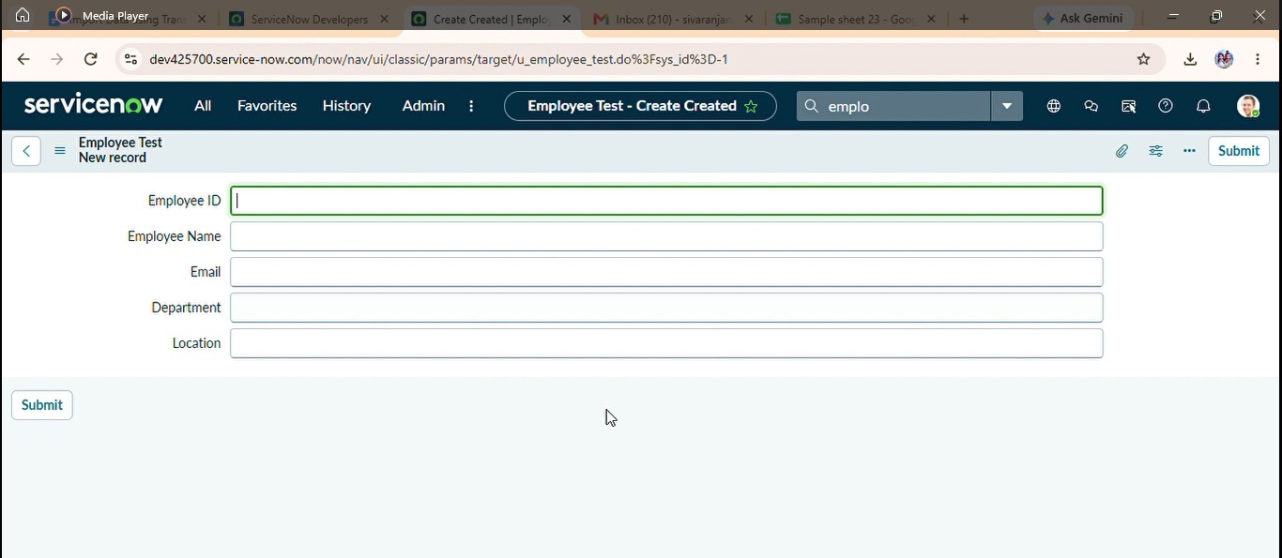

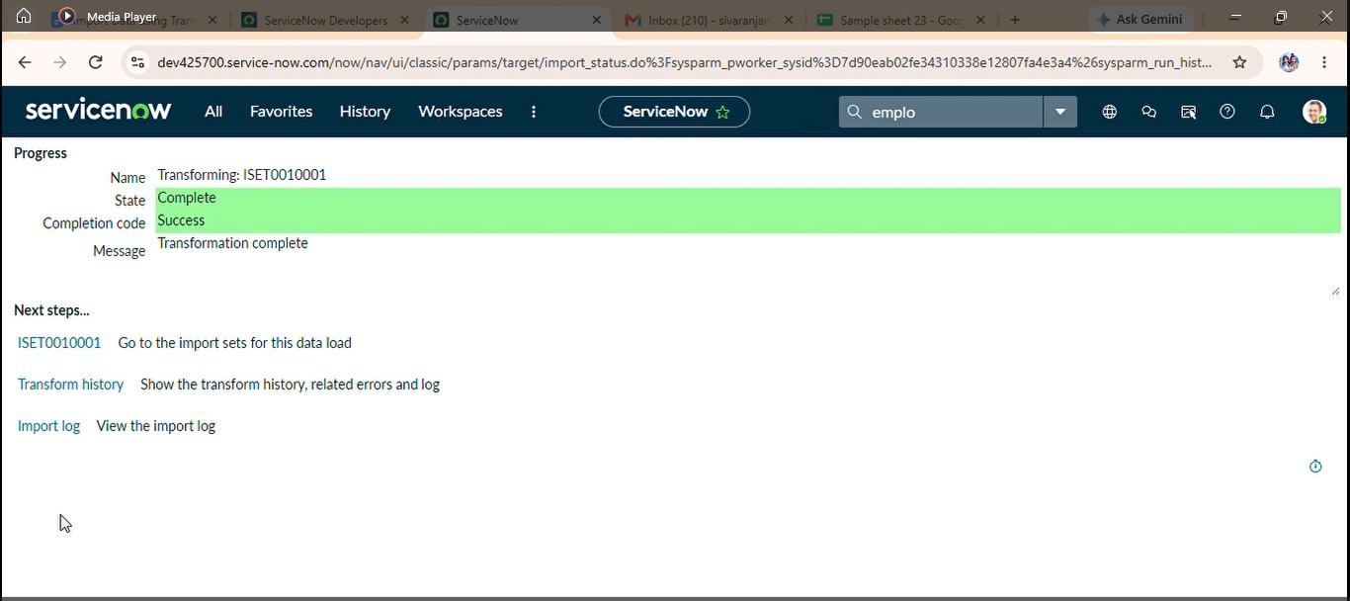

6. Phase Summary
Phase 7 completes the activities required for Project Documentation Phase. The documented output and screenshots provide evidence of the project work and support the transition to the next phase.

